

Technical Proposal for Travel Request System

Submitted by

Suresh

Sep 30, 2018

Document Management Information

Document Title: Technical Proposal for Travel Request System.

Document No: TDD V1.0

Document Status: Developer – Released / Business Trading Company - In Review

Document Publication History

(All revisions made to this document must be listed in chronological order, with the most recent revision at the top.)

|  |  |  |  |
| --- | --- | --- | --- |
| Version Number | Date | Author(s) | Remarks |
| 1.0 | Sep 30, 2018 | Suresh | Based on the email discussion & Whatapp discussion |

1 Executive Summary ......….…………………………………………………………………………………….……4

2.1 Scope of Work .........................................................................................................................................................4

2.2 Use Cases..................................................................................................................................................................5

2.3 Key Assumptions .....................................................................................................................................................5

2.4 Modification Management Process ..........................................................................................................................7

3 Development Methodology…………………………................................................................................................. 8

3.1 Technical Architecture..............................................................................................................................................8

3.2 Development Tools ..................................................................................................................................................8

3.3 Implementation Methodology ..................................................................................................................................8

3.3.1 Requirement Gathering & Design Phase ............................................................................................................8

3.3.2 Construction Phase ..............................................................................................................................................9

3.3.3 Testing Phase ......................................................................................................................................................9

3.3.4 Deploy..................................................................................................................................................................9

3.3.5 UAT & Go Live...................................................................................................................................................9

3.3.6 Deliverables ........................................................................................................................................................9

3.3.7 Payments .............................................................................................................................................................9

1. Executive Summary

Business Trading Company, also known as BTC was established in 1997 to fill the void which existed in Qatar for a retail environment offering the perfect mix of shopping, dining, and entertainment opportunities. BTC is famous both in Qatar and the entire GCC region for its proven expertise in the development and management of premium shopping malls, entertainment, real estate, and high end retail brands.

The purpose of this document is to define the scope of work, Development Approach, Out of Scope and

Support Options for the development of Travel Request System.

2.1 Scope of Work

The proposed system is a web based application portal to gather, analyze and give an in-depth insight of the Travel Request System by defining the problem statement in detail by the Business Trading Company. The proposed system manages to automate the travel request process and which will ease the employee. The main objective of the proposed system is to allow the employees to process their business travel requests quicker. When a travel request is submitted in the proposed system, it will flow to their respective departments / cost center head for approvals. If the head approves the request, it goes to HR. Once the approval process is completed and tickets are booked, the employees will be intimated. The secondary scope the proposed system is to book tickets for approved annual leave requests.

Following are the modules for the Travel Request System.

Travel Module

Travel Module contains the proposed features of the Business/Annual Travel Request System. It allows the eligible Employees with a login credential for accessing Business Travel Request system. After login, employee can create business travel requests by choosing trip type, travel date and necessary notes and submit. This module also manages the employees to book tickets for approved annual leave requests. Annual Leave Status screen helps the employee to view his/her annual leave status entered in the ESS of HR Works application (the HR application that currently working in Business Trading Company). The employees have the provision to view his profile and he/she can change password.

Approval Module

When a travel request is submitted in the proposed system, it will flow to their respective departments / cost center head for approvals and then the system automatically forward the approved request to HR department. Travel Coordinator request for quotes to the travel agency and enters received quotes from agency to the proposed system. Travel Coordinator compares the quotes and prepare LPO based on selected quote. Once the LPO is generated, tickets are booked and employee will receive an email with the uploaded ticket. The Approver will receive notification of each travel request and its approval on his dashboard per the approval hierarchy.

Administration Module

Administration module helps admin users to manage the employees and creates users. The admin user can create the approval hierarchy per the department or employee. The users can access their screens according to the role they are defined. Only the administrator user has the rights/permission to set/manage the user roles and approval hierarchy.

Reports

This module contains custom reports like checklist, summary & registers in period wise. All reports can be exported to excel files.

2.2 Use Cases

|  |  |  |
| --- | --- | --- |
| Sl. No | Module | Use Cases (Screen) |
| 1 | Travel Module |  |
| 1.1 |  | Login |
| 1.2 |  | Dashboard |
| 1.3 |  | Business Travel Request |
| 1.4 |  | Manage Annual Leaves |
| 1.5 |  | Annual Travel Request |
| 1.6 |  | Employee Profile |
| 1.7 |  | Change Password |
| 1.8 |  | Reset password |
| 2 | Administration Module |  |
| 2.1 |  | Login |
| 2.2 |  | Dashboard |
| 2.3 |  | Manage Users |
| 2.4 |  | Manage Employees |
| 2.5 |  | Organize Approval Hierarchy |
| 3 | Approval Module |  |
| 3.1 |  | Login |
| 3.2 |  | Dashboard |
| 3.3 |  | Notification |
| 3.4 |  | Manage Travel Agency |
| 3.5 |  | Manage Quotes |
| 3.6 |  | Manage LPO |
| 4 | Reports |  |
| 4.1 |  | Period wise Travel Request |
| 4.2 |  | Travel Agency Checklist |
| 4.3 |  | Travel Agency Quotes Summary |
| 4.4 |  | Travel Agency Quotes Register |
| 4.5 |  | Approved Travel Quote Summary |
| 4.6 |  | Approved Travel Quote Register |
| 4.7 |  | LPO Register |
| 4.8 |  | LPO Summary |

* 1. Key Assumptions
* BUSINESS TRADING COMPANY is currently in the process of developing a Customized application for Travel Request System for their Employees.
* BUSINESS TRADING COMPANY will provide the hosting space and database space needed to host the Travel Request System portal.
* BUSINESS TRADING COMPANY need to provide Developer with all content, Images and logo needed for the Travel Request System.
* BUSINESS TRADING COMPANY needs to provide Developer with access to HR Work’s application and database for getting the employee data to run the Travel Request System.
* BUSINESS TRADING COMPANY needs to provide documentation to Developer with workflow of employee data HR Work’s application and its database.
* These are all suggested scope of the Travel Request System and the final proposal can be discussed and finalized with the Business Trading Company, based on the Whatapp and email conversation with Deepu
* Any functionality not mentioned in the Scope of Work & Use cases Section will be considered as out of Scope once the proposal is accepted.
* AS BUSINESS TRADING COMPANY is looking to complete the project in max 80 days’ period, BUSINESS TRADING COMPANY support is required in terms of arranging the end users for requirement gathering session, timely approval of SRS and design documents, testing and acceptance of delivered modules. As these activities are highly related to achieving the milestones, any delay in these activities shall cause a delay in the project delivery and shall not be responsible for such delay.
* BUSINESS TRADING COMPANY would provide Developer with access to appropriate resources (In case required e.g. facilities, workspace, computers, network system, documentation, subject matter expertise, compatible hardware, HR Works database) necessary to complete the engagement.
* BUSINESS TRADING COMPANY would promptly review deliverables. Any work not accepted by BUSINESS TRADING COMPANY must be communicated to Developer in writing within 2-4 business days by the IT team and 2 weeks by the business. Otherwise, such work shall be deemed as accepted.
* Developer will not be responsible for any delay due to applications/hardware or other associated infrastructure of BUSINESS TRADING COMPANY.
* Any change requests would be taken through the Change Request Channel. Developer would come up with the effort estimation and commercials for the change requests. For any Change Request that may arise after freezing the SRS, BUSINESS TRADING COMPANY & Developer will follow the Change Management Request Process. The estimated efforts for Change Request will be shared with BUSINESS TRADING COMPANY. The change request shall be considered for the following
  + Additional module or process.
  + Additional functionality within the module.
  + Major design change to existing functionality.
  + Minor changes, enhancements and Features are not considerable changes.
* The source code & components developed for BUSINESS TRADING COMPANY will be handed over to BUSINESS TRADING COMPANY.

2.4 Modification Management Process

* Any necessary or desired modifications identified to the project scope past the commencement of the project or during the project period date would be accommodated only by following the modification management procedure, to diminish any resultant risks to project success.
* Request for modification may either be raised by client or Developer. All change requests are to be approved by both. Consequently, only approved change requests will be added to project scope.
* Approved changes to the project scope would result in a recalculation of the effort estimate and a shifting of delivery deadlines.
* To facilitate timely commencement of the project, Developer would like to propose that there be a cutoff date for changes, close to the final delivery date of the project. Change requests raised beyond this date may not be added to the project scope.

3 Development Methodology

3.1 Technical Architecture

The V-model is an SDLC model where execution of processes happens in a sequential manner in a V- shape. It is also known as Verification and Validation model. The V-Model is an extension of the waterfall model and is based on the association of a testing phase for each corresponding development stage. This means that for every single phase in the development cycle, there is a directly associated testing phase. This is a highly-disciplined model and the next phase starts only after completion of the previous phase.

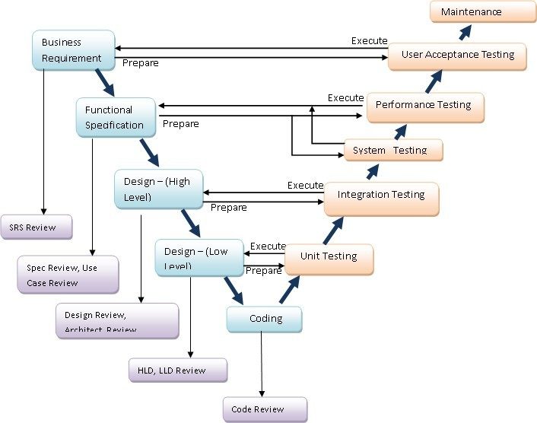

3.2 Development Tools

* Dot Net (MVC, MVVM, C#)
* Web Api
* Angular Js, Jquery
* MS SQL

3.3 Implementation Methodology

The Project will be implemented in Offshore Model and the distribution of activities is detailed below.

Requirement Gathering and Knowledge Transfer from Business Trading Company - Offshore Activity

Due Diligence, Checking for Code Standards, Correction of Code, Enhancement of Look & Feel and Testing - Offshore Activity

Deployment & training of Updated Code after Integration Testing - Offshore Activity (Remotely)

3.3.1 Requirement Gathering & Design Phase

* Requirement Blue Print
  + Initial Project Planning
  + Understand the Project Vision / Mission Statement & metrics
  + Workshops from the core team of BUSINESS TRADING COMPANY on the study and discovery of needs done
  + Determine Project Acceptance strategy
* Requirement Gathering
  + Conduct Line Manager / IT / Project Team - BUSINESS TRADING COMPANY meetings
  + Create Role Report
  + Create Information Packages for BUSINESS TRADING COMPANY Core team
* Technical / UI Design Planning
  + Create Technical Design
* Requirement Specifications
  + Validate & Analyze requirements
  + Clarify Deficient Areas
  + Determine Enterprise Standards
  + Determine the Need for Extended Functions
  + Identify Baseline Scope
  + Verify Business Blueprint Completeness
  + Obtain Approval
  + Sign-Off the Business Blueprint Phase

3.3.2 Construction Phase

* Validate Functionality & Data
* Phase Rollout Roadmap by Business Criticality, Users, etc.

3.3.3 Testing Phase

* Functional Testing
* Creation of Detailed Test Plan (DTP) for CUT & SIT
* Test Preparation -Test Requirements definition, High level test cases, detailed Test cases and Traceability Matrix
* Transaction data definition
* Test Execution
* Test results reporting

3.3.4 Deploy

* Optimize Performance of Target Infrastructure
* Deploy applications and validate

3.3.5 UAT & Go Live

* Perform User Acceptance Test
* Validate Acceptance Test
* Deploy Applications in Production Environment
* Go Live

3.3.6 Deliverables

* Project Initiation & Design
* Original Development Code
* Testing & Staging
* Installation, Configuration and Deployment Docs

3.3.7 Payments

If the above details are the intended details for the development and no other major changes the project will be completed in anything between 45-80 days. Projected cost for Development, Testing and Deployment combined will be 1200$ USD

The payment for the entire project would more advisable to be in installments after each deliverable. Preferably in 3 installments

* 20% upfront
* 30% after the product is built of demo
* 50% after final product is deployed and tested

Since I would be working on a part time basis, I will be spending on an average of 4 hrs. daily also the website will be designed in way that will make it compatible with mobile or easy to integrate with other applications.